

Report🔎

**[Data Analysis Project Using Python]**

**2024| Presented By Joy Paul**

**Hotel Booking Cancellation**

**Data Analysis Project**

**Business Problem🎯**

* In recent years, City Hotel and Resort Hotel have seen **high cancellation rates.** Each hotel is now dealing with a number of issues as a result, including fewer revenues and less than ideal Hotel room use. Consequently, lowering cancellation rates is both Hotel's primary goal in order to increase their efficiency in generating revenue and for us to offer thorough business advice to address this problem
* The analysis of hotel booking cancellations as well as other factors that have no bearing on their business and yearly revenue generation are the main topic of this report.

**Assumptions**

1. No unusual occurrences between 2015 and 2017 will have a substantial impact on the data used.
2. The information is still current and can be used to analyze a hotel's possible plans in an efficient manner
3. There are no unanticipated negatives to the hotel employing any advised technique.
4. The hotels are not currently using any of the suggested solutions.
5. The biggest factor affecting the effectiveness of earning income is booking cancellations.
6. Cancellations result in vacant rooms for the booked length of time.
7. Clients make hotel reservations the dame year they make cancellations.

**Research Questions**

1. What are the variables that affect hotel reservation cancellations?
2. How can we make hotel reservations cancellations better?
3. How will hotels be assisted in making pricing and promotional decisions?

**Hypothesis**

1. More cancellations occur **when prices are higher**.
2. When there is a longer waiting list, Customers tend to cancel more frequently.
3. The **majority of clients are coming form offline travel agents** to make their reservations.

**Analysis and finding:**

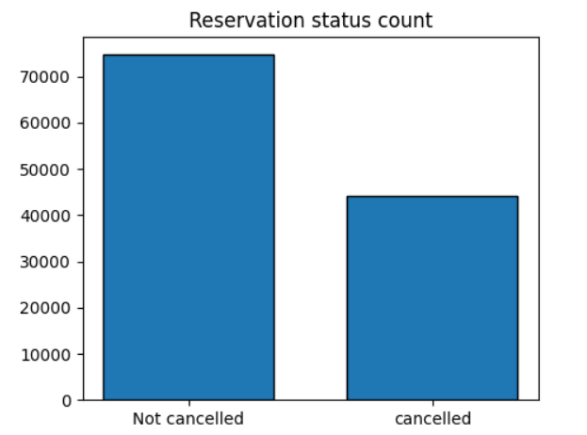

* The accompanying bar graph shows the percentage of reservation that are canceled and those that are not. It is observe that there are still a significance number of reservations that have not been canceled. There are still 37% of clients who canceled their reservation, Which had significant impact on the hotel’s earnings.

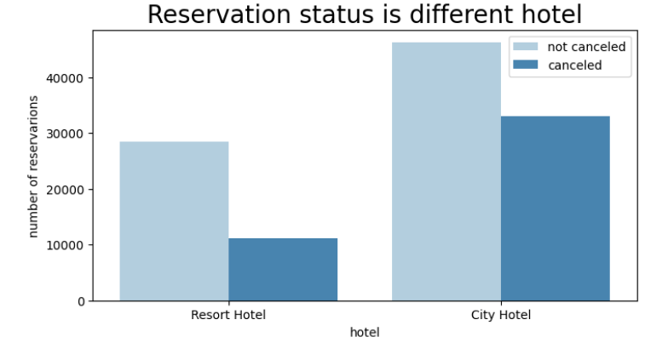

* In comparison to resort hotels , city hotels have note booking , It’s possible that report hotels are more expensive than those in cities.

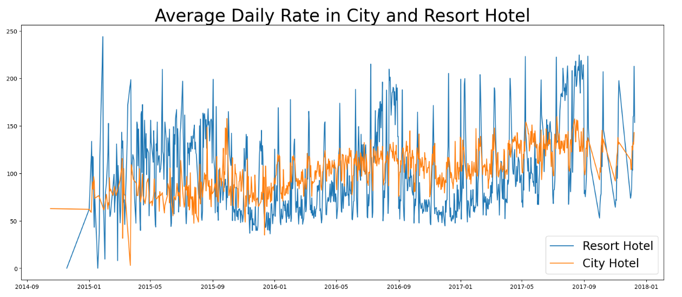

* The line graph above shows that, on certain days, the average daily rate for a city hotel is less then that of a resort hotel, and on other days, It is even less. It goes without saying that weekends day and holidays may see a rise in resort hotel rates.

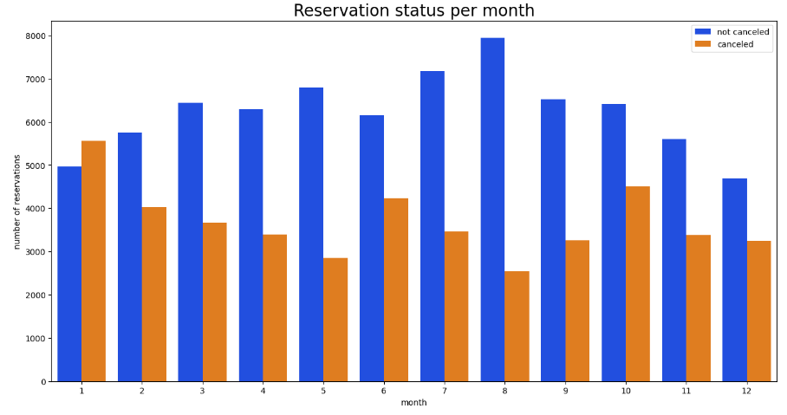

* We have developed the grouped bar to analyze the month with the highest and lowest reservation levels according to reservation status. As can be seen, both the number of confirmed reservations and a number of canceled reservations are the largest In the month of August. Whereas January is the month with the most canceled reservations.

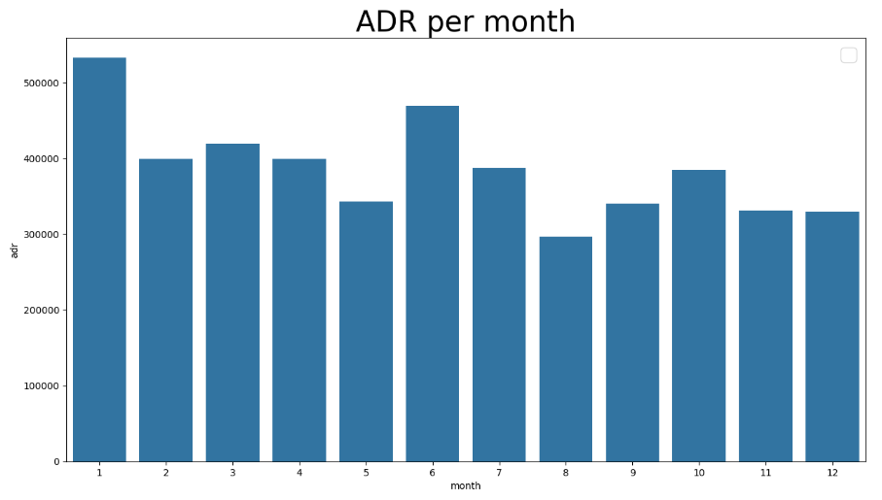

* This bar graph demonstrates that cancellations are most common when price are greatest and are least common when they are lowest. Therefore, the cost of the accommodation is solely responsible for the cancellation.

Now , Let’s which country has the height reservation canceled. The top country is Portugal with the height number of cancellations

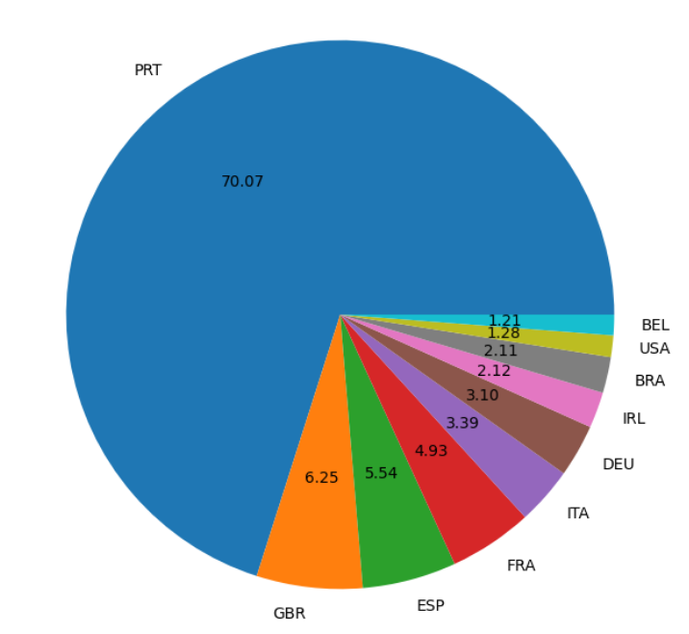

Let’s check the area from where guests are visiting the hotels and making reservations. Is it coming from Direct or Groups, online Travel Agents? Around 46% of the clients come from travel agencies, whereas 27% come from groups. Only 4% of clients book hotels directly by visiting them making reservations.

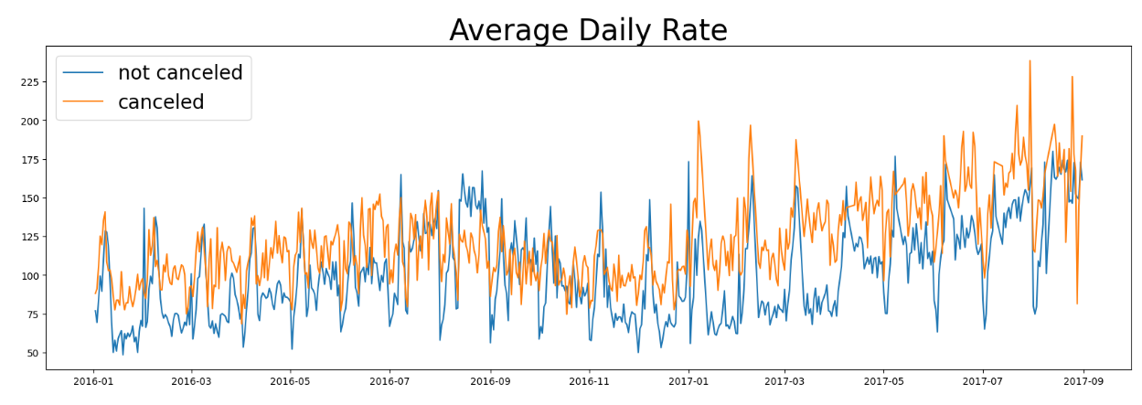

* As seen in the graph , reservations are canceled when the average daily rate is higher than when it is not canceled. It clearly proves all the above analysis , that higher price leads to higher cancellation

**Suggestion**

* + Cancellation rates rise as the price does. In order to prevent cancellation of reservations, hotels could work on their pricing strategies and try to lower the rate for specific hotels based on locations. They can also provide some discounts to consumers.
  + As the ratio of cancellations and non-cancellations of the resort hotel is higher in the resort hotel than in the city hotel. Does the hotel provide a reasonable discount on the room price on weekends or on holidays?
  + In the month of January hotels can start campaigns or marketing with a reasonable amount to inverse their revenue as the cancellations are the highest in this month
  + They can also increase the quality of their hotel and their services mainly in Portugal by reducing the cancellation rate

Report🔎

**[Data Analysis Project Using Python]**

Report🔎

**[Data Analysis Project Using Python]**